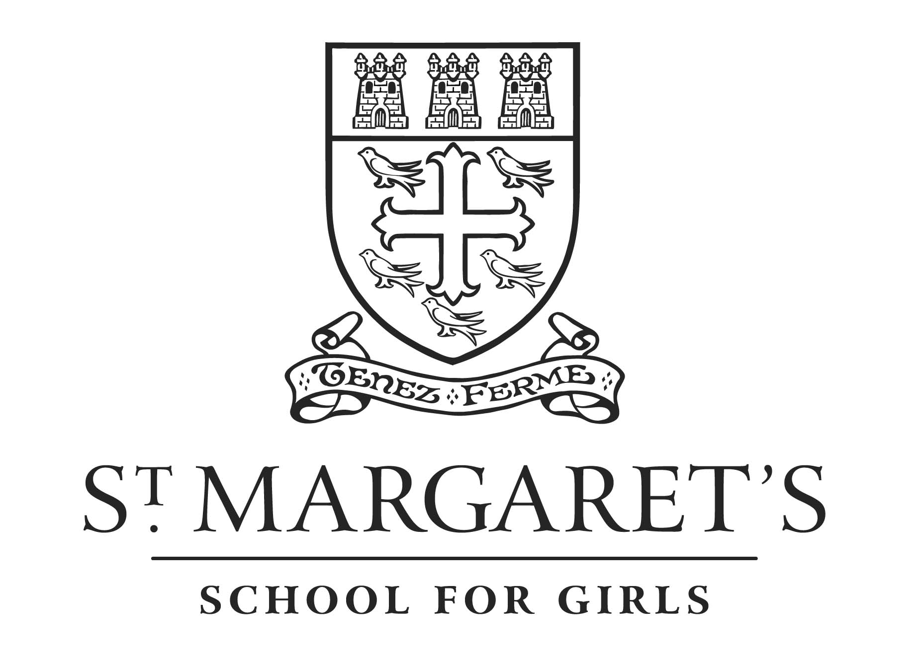
17 Albyn Place, ABERDEEN, AB10 1RU

Health & Safety Briefing

All girls must return “The Code of Conduct for Work Experience Placement” form which must be signed by both the parents and participant.

- Participants must pay close attention to the Health & Safety instructions given to them by their host company at the start of the placement.
- It is the responsibility of the participant to ensure that they know the fire signal, test times of the signal, the location of the fire exits and fire muster points

- You will be classified in law as an employee of the company or organisation providing the placement (even though you are not being paid) and you are therefore bound by the same regulations as the people that work there.

- You do have a responsibility in the workplace or on any associated visit to other people, whether employees or clients/customers. Do not do anything which may endanger them
- Participants are responsible for their own personal belongings whilst at the placement and must take due care of them.
- Participants are responsible for their own safety and must therefore talk to their placement host if they feel that they are being asked to do something that they consider unsafe.
- If at any time a participant feels uncomfortable in a situation they find themselves then they must extradite themselves as speedily as possible.
At all times participants are welcome to contact school to discuss any concerns that they may have about placements.

s.brown@st-margaret.aberdeen.sch.uk
Tel 01224 584466

